- Setup Minikube in your local machine.
What is Minikube?
minikube is local Kubernetes, focusing on making it easy to learn and develop for Kubernetes.
All you need is Docker (or similarly compatible) container or a Virtual Machine environment, and Kubernetes is a single command away: minikube start

What you’ll need
- 2 CPUs or more
- 2GB of free memory
- 20GB of free disk space
- Internet connection
- Container or virtual machine manager, such as: Docker, QEMU, Hyperkit, Hyper-V, KVM, Parallels, Podman, VirtualBox, or VMware Fusion/Workstation
Step-by-Step Fix for Chocolatey Lock Error

1.Close all PowerShell/Command Prompt windows
Make sure no other Chocolatey processes are running.
Then open a new PowerShell as Administrator
(Search “PowerShell” → right-click → Run as administrator)

2. Stop any stuck Chocolatey processes
Run this:
taskkill /F /IM choco.exe /T
taskkill /F /IM chocolatey.exe /T
Ignore errors if it says “no such process”.
3. Delete old lock files
Run these:
Remove-Item -Force "C:\ProgramData\chocolatey\lib\*.lock" -ErrorAction SilentlyContinue
Remove-Item -Force "C:\ProgramData\chocolatey\lib-bad" -Recurse -ErrorAction SilentlyContinue
Then remove the corrupted temp folder mentioned in your error:
Remove-Item -Recurse -Force "C:\ProgramData\chocolatey\lib\c1eedec61dc9e765bad7820a51b7d76298cbb8e7" -ErrorAction SilentlyContinue

4.Clear Chocolatey’s cache
choco clean –y
5.Retry the installation (as Administrator)
Now re-run:
choco install minikube kubernetes-cli –y

Set the minikube path to environmental varaible:

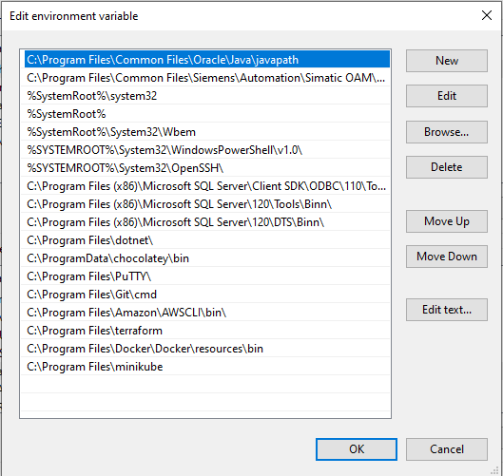
💡 If you get an error again, try installing them separately:
choco install minikube -y
choco install kubernetes-cli –
6. Verify installation
After success:
minikube version
kubectl version --client
If both show version numbers, you’re ready.
7. Start Minikube
Make sure Docker Desktop is installed and running,
then run:
minikube start --driver=docker

8. Check Cluster Status
kubectl get nodes
You should see:
NAME STATUS ROLES AGE VERSION
minikube Ready control-plane 2m v1.30.0

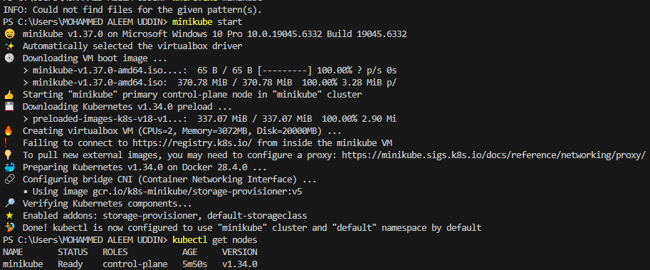
- Setup k8s master and two worker nodes on ubuntu.
What is K8s?
Kubernetes (k8s): It is an open-source platform for automating deployment, scaling, and management of containerized applications. Think of it as a manager for containers that makes sure your apps run reliably across multiple machines.

Kubernetes Cluster Setup (Master + 2 Workers on Ubuntu)

Prerequisites
- 3 Ubuntu 20.04+ systems (VMs or cloud instances)
  - 1 Master Node
  - 2 Worker Nodes
- Minimum requirements:
  - 2 GB RAM (master), 1 GB (workers)
  - 2 vCPUs
- User with sudo privileges
- Internet connectivity
- Unique hostnames (example):
  - Master: k8s-master
  - Worker1: k8s-worker1
  - Worker2: k8s-worker2
Step 1: Configure All Nodes
Run the following on all three nodes 👇
# Update system
sudo apt update -y && sudo apt upgrade -y

# Disable swap
sudo swapoff -a
sudo sed -i '/ swap / s/^/#/' /etc/fstab

# Enable required modules
sudo modprobe overlay
sudo modprobe br_netfilter

# Add required sysctl params
cat <<EOF | sudo tee /etc/sysctl.d/kubernetes.conf
net.bridge.bridge-nf-call-iptables = 1
net.bridge.bridge-nf-call-ip6tables = 1
net.ipv4.ip_forward = 1
EOF

sudo sysctl –system

Step 2: Install Container Runtime (containerd)
sudo apt install -y containerd
sudo mkdir -p /etc/containerd
containerd config default | sudo tee /etc/containerd/config.toml >/dev/null 2>&1
sudo sed -i 's/SystemdCgroup = false/SystemdCgroup = true/' /etc/containerd/config.toml
sudo systemctl restart containerd
sudo systemctl enable containerd
Step 3: Install Kubernetes Tools (kubeadm, kubelet, kubectl)
Run on all nodes:
sudo apt install -y apt-transport-https ca-certificates curl gpg
sudo curl -fsSL https://pkgs.k8s.io/core:/stable:/v1.30/deb/Release.key | sudo gpg --dearmor -o /etc/apt/keyrings/kubernetes-apt-keyring.gpg
echo "deb [signed-by=/etc/apt/keyrings/kubernetes-apt-keyring.gpg] https://pkgs.k8s.io/core:/stable:/v1.30/deb/ /" | sudo tee /etc/apt/sources.list.d/kubernetes.list
sudo apt update
sudo apt install -y kubelet kubeadm kubectl
sudo apt-mark hold kubelet kubeadm kubectl
Step 4: Initialize Kubernetes Master Node
Run this only on the master node:
sudo kubeadm init --pod-network-cidr=192.168.0.0/16
Note: The --pod-network-cidr depends on your CNI (Calico uses 192.168.0.0/16, Flannel uses 10.244.0.0/16).
When it finishes, it will show a command like:
kubeadm join <master-ip>:6443 --token <token> --discovery-token-ca-cert-hash sha256:<hash>
Copy that — you’ll need it for the workers.
Step 5: Set Up kubectl Access (on Master)
mkdir -p $HOME/.kube
sudo cp -i /etc/kubernetes/admin.conf $HOME/.kube/config
sudo chown $(id -u):$(id -g) $HOME/.kube/config
Check:
kubectl get nodes
You’ll see the master node (in NotReady state for now — that’s OK).
Step 6: Install Pod Network Add-On (Calico)
kubectl apply -f https://docs.projectcalico.org/manifests/calico.yaml
Wait 1–2 minutes, then check:
kubectl get pods -A
kubectl get nodes
The master should now show Ready.
Step 7: Join Worker Nodes
Run the kubeadm join command you copied from Step 4 on both worker nodes.
Example:
sudo kubeadm join 192.168.1.10:6443 --token abcdef.0123456789abcdef \
--discovery-token-ca-cert-hash sha256:1234567890abcdef...
After that, go back to the master node and check:
kubectl get nodes
You should now see:
NAME STATUS ROLES AGE VERSION
k8s-master Ready control-plane 10m v1.30.x
k8s-worker1 Ready <none> 3m v1.30.x
k8s-worker2 Ready <none> 2m v1.30.x

Step 8: Verify Cluster
kubectl get pods -A
kubectl get nodes -o wide
Everything should show as Ready.
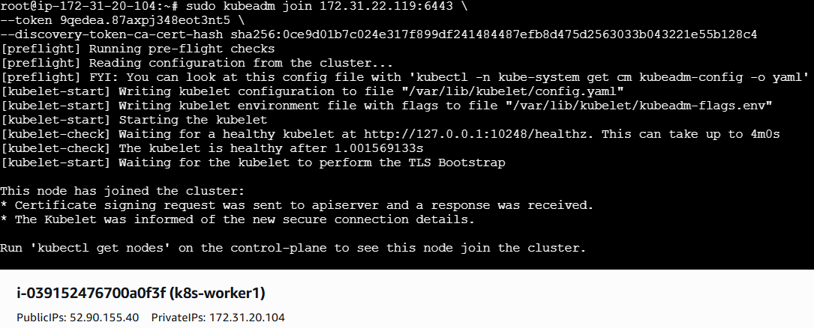
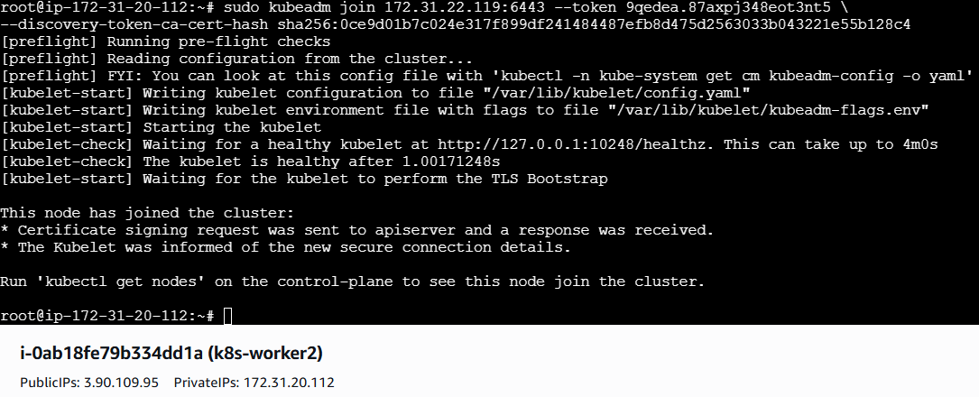
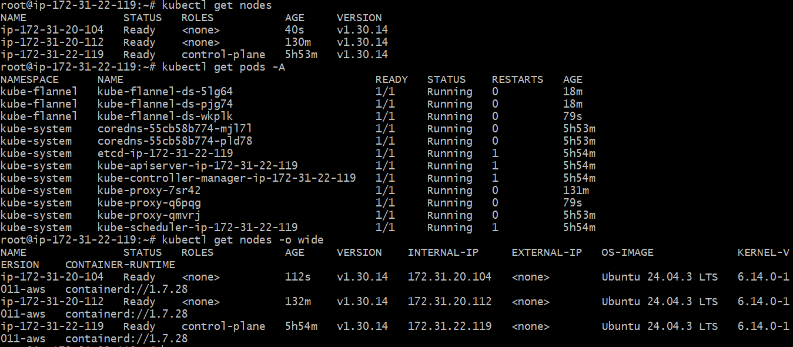

- Run one nginx pod.
In Kubernetes, a Pod is the smallest and simplest unit that you can create and manage. It represents a single instance of a running process in your cluster. Think of it as a wrapper around one or more containers that need to work together.
Pod vs Container
Container: Single application process.
Pod: Encapsulates one or more containers with shared networking and storage.

Simple Analogy
- Pod = Apartment
- Containers = Rooms inside the apartment
- They share common utilities (network, storage), but each room can have its own function.

Option 1: Using kubectl run (Quick way)
kubectl run my-nginx --image=nginx --restart=Never
- my-nginx → name of the Pod
- --image=nginx → use the official Nginx image
- --restart=Never → ensures this creates a Pod (not a Deployment)
Check if the Pod is running:
kubectl get pods
You should see something like:
NAME READY STATUS RESTARTS AGE
my-nginx 1/1 Running 0 10s
Access Pod logs:
kubectl logs my-nginx

Option 2: Using a YAML manifest
Create a file called nginx-pod.yaml:
apiVersion: v1
kind: Pod
metadata:
name: my-nginx
labels:
app: nginx
spec:
containers:
- name: nginx
image: nginx
ports:
- containerPort: 80
Apply it:
kubectl apply -f nginx-pod.yaml
Check Pod status:
kubectl get pods
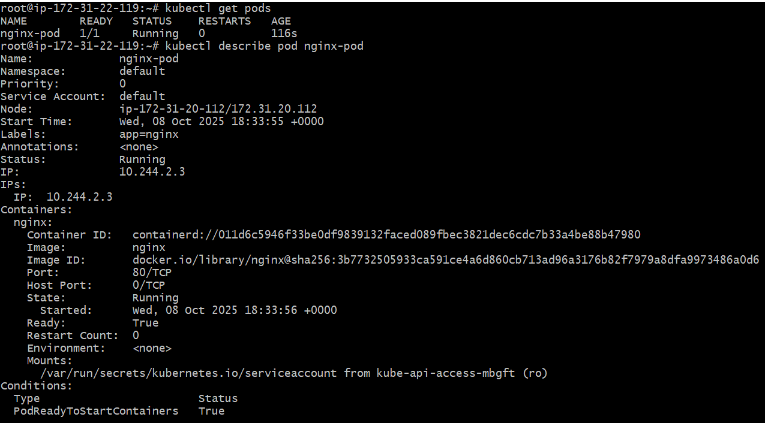
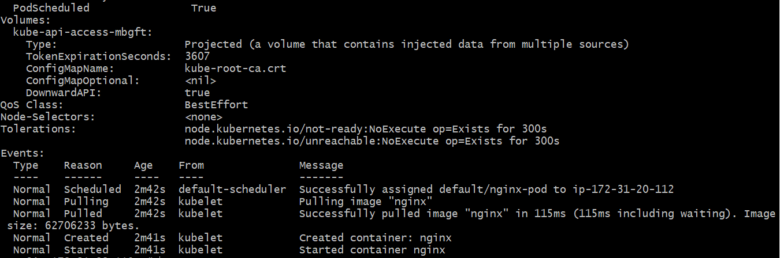

- Mug up Master and slave components on k8s.
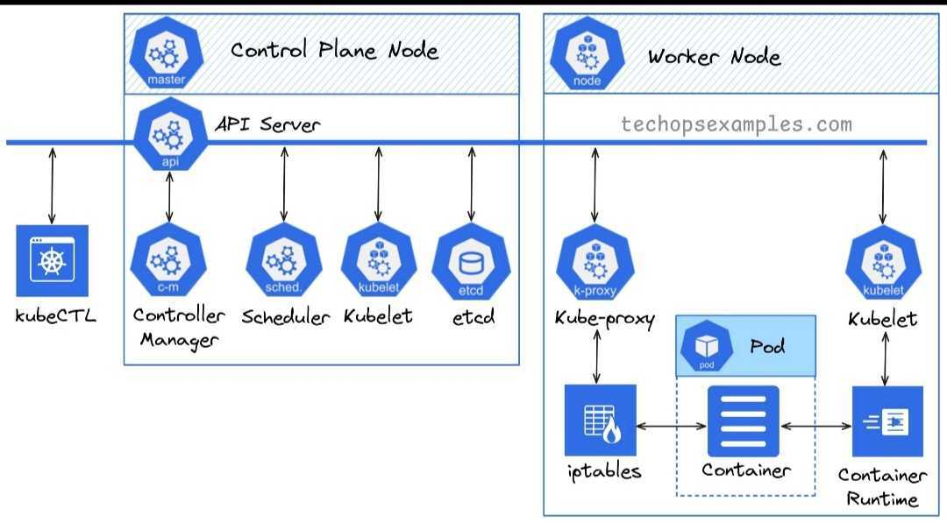
Kubernetes Master Components
The Master Node is responsible for managing the cluster — scheduling, maintaining cluster state, and controlling workloads.
Component | Purpose
kube-apiserver | Exposes Kubernetes API. All commands go through this. Think of it as the “gateway” of the cluster.
etcd | Distributed key-value store for cluster data (configuration, state, secrets).
kube-scheduler | Decides which node a pod should run on based on resources, constraints, and policies.
kube-controller-manager | Runs various controllers to maintain cluster state (replication, endpoints, nodes).
cloud-controller-manager | Manages cloud-specific control logic (if running on cloud provider).
Memory trick: “ASK EC to SCHEDULE CONTROLLERS in the CLOUD”
- Api-server
- Scheduler
- Kube-controller-manager
- Etcd
- Cloud-controller-manager

Kubernetes Worker (Slave) Components
The Worker Node runs the actual workloads (pods) and communicates with the master.
Component | Purpose
kubelet | Agent that runs on each node; ensures containers in pods are running.
kube-proxy | Handles networking, load balancing, and forwarding traffic to pods.
Container Runtime | Software that runs containers (e.g., Docker, containerd, CRI-O).
Memory trick: “LET’S PROXY CONTAINERS”
- L = kubelet
- P = kube-proxy
- C = Container runtime

